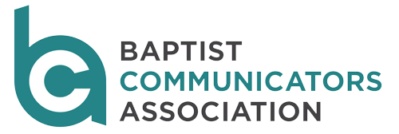
Retired/Student Membership
(may be combined with New Member/Renewal form)
BCA's fiscal year runs from July 1 thru June 30. Please take a moment to complete this form and return it with the appropriate payment to obtain membership. If you have questions about membership in BCA, please contact BCA executive director Margaret Colson at (678) 641-4457 or margaretcolson@bellsouth.net.
Membership fees are $25 for each retired or student member.
Make checks payable to Baptist Communicators Association and send along with this form to:
Margaret Colson
Baptist Communicators Association
4519 Lashley Court
Marietta, GA 30068
BCA sponsors seven affinity groups designed to provide members with specialized training and foster fellowship between colleagues. Please include one affinity group that best matches your interests on the form below.
Editorial | Electronic Media | Graphic Design | Management | Marketing | Photography | Public Relations
Name: ____________________________________________________________________________________
Affiliated Organization:_______________________________________________________________________
Mailing Address:____________________________________________________________________________
City, State, ZIP: ______________________________________________________________________________
Desired Affinity Group: _________________________Cell Phone: ___________________________________
Email: _______________________________________ Personal Website: ______________________________
Twitter Handle:________________________________ Facebook Username: ___________________________

